Name __________________________________ Acc Geometry/ Adv Alg
Date______________ Period ______________ 11.1 – 11.2 Test Review

List the possible rational roots of the following functions
$1) f\left(x\right)=x^{2}-5x+12$ $2) f\left(x\right)={{2x}^{2}-5x}^{3}-15+10x$

Solve for the zeros of each function using the method of your choice.
3) $f\left(x\right)= {-x}^{3}-5x^{2}-4x-20$ 4) $f\left(x\right)= x^{4}-8x^{3}-38x^{2}+360x-315$

5) $f\left(x\right)= {14x}^{3}-25x^{2}-8x+4$ 6) $f\left(x\right)= {-3x}^{5}+6x^{4}+18x^{3}$

7) $x^{3}-9x^{2}+33x-25=0$ 8) $6x^{3}-17x^{2}-27x-4=0$

9) 10) $x^{5}+{x^{4}-7x}^{3}-7x^{2}-18x-18=0$
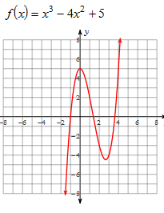

$$11) 3x^{5}+21x^{3}=54x { 12) 3x}^{5}-x^{4}-2x^{3}=0$$

Write a polynomial function with the given zeros.
$13) 2+4i, \frac{1}{3}$ $14) 0\left(mult of 4\right), 3\sqrt{5} , -3i$

