Name ________________________________________ Accel Geom/Adv Alg
Date _____________________ Period _____________ 11.1/11.2 Finding Zeros

List the possible rational roots for the following polynomial functions.
1. ${x^{4}+3x}^{3}-2x^{2}+6x-18$ 2. ${3x}^{3}-6x^{2}+12$

Impress me! Sketch a graph of a polynomial function given the following zeros.
3. 4, 4, 0 4. -2, -2, -2, 5
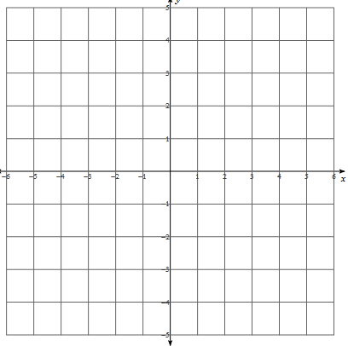

Find the roots of the polynomial functions.
5. ${-3x}^{3}+{3x}^{2}+90x=0$ 6. ${12x}^{3}-20x^{2}+21x-35=0$

7. $y=x^{3}+x^{2}-3x-3$ 8. $x^{5}+3x^{4}-7x^{3}=0$

9. ${f\left(x\right)=x}^{4}-2x^{2}-15$ 10. ${y=3x}^{3}+5x^{2}+x-1$

11. $f\left(x\right)={x^{4}-7x}^{3}+13x^{2}+x-20$ 12. $x^{3}-4x^{2}-2x+20=0$
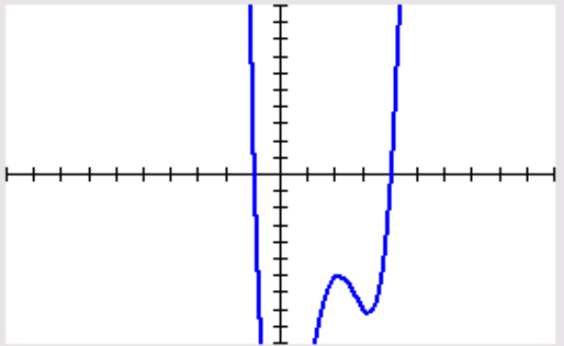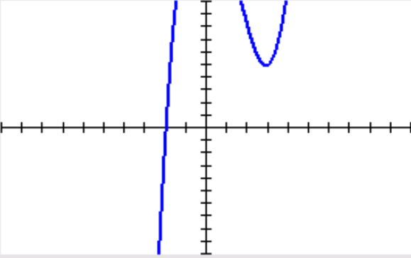

13. $x^{4}-3x^{3}-x^{2}-9x-12=0$ 14. $15x^{3}-47x^{2}+38x-8=0$
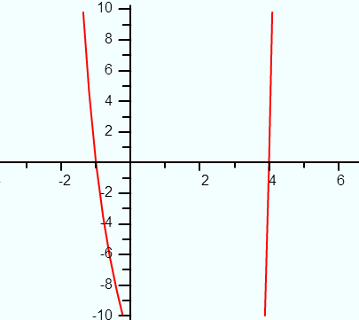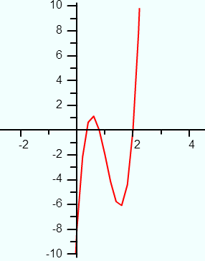

15. $f\left(x\right)=x^{5}+x^{4}-5x^{3}-x^{2}+8x-4$ 16. $x^{3}-64x=0$
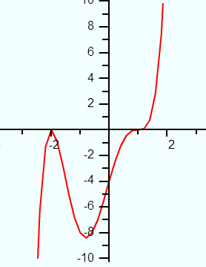

17. $x^{4}-5x^{2}-24=0$ 18. ${f\left(x\right)=x}^{4}+2x^{3}-11x^{2}-12x+36$
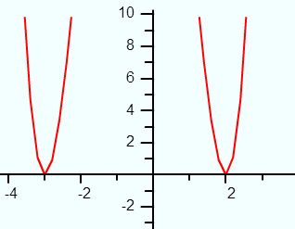

Write the simplest polynomial function with the given roots.
19. -2, 0, 4 20. -3 (multiplicity of 3), 2/3

21. -1, -2i 22. $\sqrt{7}$, 5(multiplicity of 2)

