Accelerated Geometry Name_______________________
Circles Review Period_______
1) Write the equation of a circle in standard form with center (0, 6) and r = $3\sqrt{7}$ | 2) Write the equation of a circle in general form with center (-2, 6) and r = $8$
3) What is the center and radius of the following circle?  $${(x-9)}^{2}+y^{2}=98$$ | 4) What is the center and radius of the following circle?  $$x^{2}-6x+y^{2}+9y=1$$
5) Find the center and radius of the following circle?  $$8y^{2}-64=-8x^{2}+64y-8$$ | 6) Write the equation of the following circle in standard form:  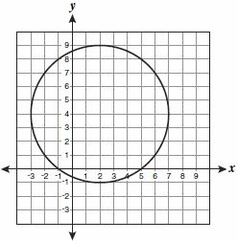
7) Find each measure.  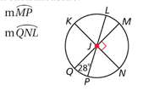 | 8) Find each measure.  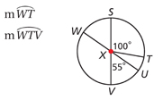
9) Does the point (-4, -4) lie in, on, or outside of the circle centered at (3, -5) and containing the point (5, 2)? | 10) Find the measure of the arc or angle indicated  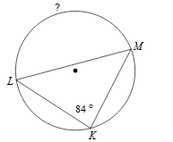
11) Solve for x.  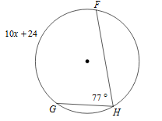 | 12) Find the measure of the arc or angle indicated  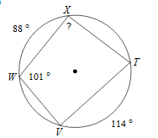
13) Find x, y, z  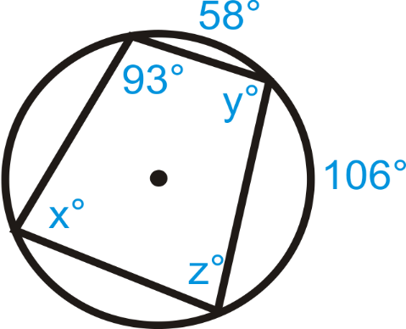 | 14) Find the measure of the arc or angle indicated.  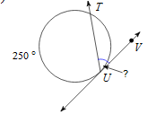
15) Solve for x.  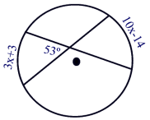 | 16) Solve for x.  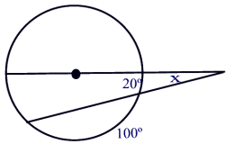
17) If $m<2=72$ and $m\hat{BC}=106$, find $m<1$  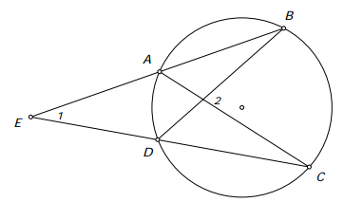 | 18) Find the exact circumference given the area of the circle
19) Find the length of the arc as an exact measurement.  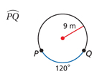 | 20) Find the area of the sector as an exact measurement.  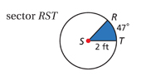
21) Find the length of the radius as an exact measurement.  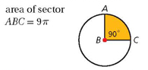 | 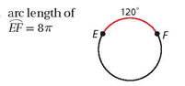  22) Find the length of the radius as an approximate measurement.
23) 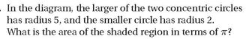  Answer in both exact and approximate.  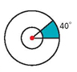 | 24) Find the measure of the central angle. Round to the nearest tenth.  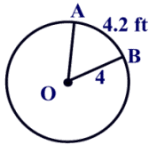
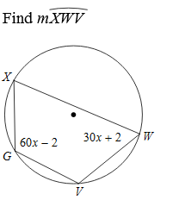  25) | 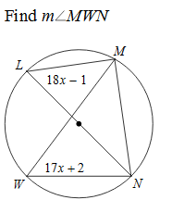  26)
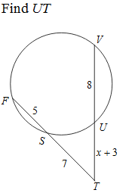  27) | 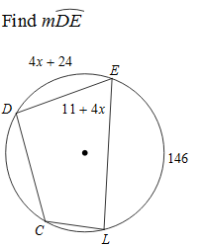  28)
29)  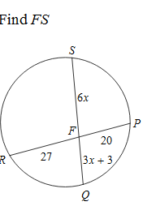 | 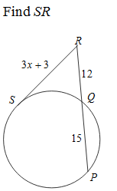  30)
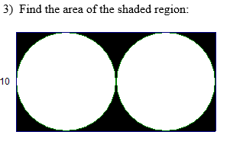  30) Round to the nearest tenth. | 31)  