Name:_________________________ Adv. Alg. Fall BM 2 Review
Date:__________________________
Add or Subtract. Write the polynomial in standard form. Identify the leading coefficient, degree, and number of terms. Name the polynomial
$1) \left({3x}^{4}-{6x}^{2}+8\right)-({-5x}^{4}+x^{2}-10)$ $2) \left(-2x^{3}+3x^{5}-3\right)+({4x}^{2}+{3x}^{3}+12x^{5})$
Standard Form: Standard Form:
Leading Coefficient: Leading Coefficient:
Degree: Degree:
Number of Terms: Number of Terms:
Name: Name:
Identify the degree of the following monomials:
3) ${3x}^{5}y^{2}$ 4) 9 5) $x^{10}$

Expand the expressions.
$6) {(x-2)}^{5}$ $7) {(x+y)}^{3}$

Divide the following polynomials by the method of your choice.
$8) \left(3x^{3}+{9x}^{2}-14\right)÷(x+2)$ $9) \left(15x^{3}-16x^{2}+x-2\right)÷(x-2)$

Simplify the following radicals.
$10) 2\sqrt{-200}$ 11) $-3\sqrt{-32}$ 12)$\sqrt{\frac{72}{144}}$

Simplify the following expressions.
$13) (3+4i)(1-6i)$ 14) $\left(5-12i\right)-4(3-i)$

15) $\frac{3+5i}{4-2i}$ 16) $\frac{-i}{6+5i}$

Simplify using powers of i.
17) $i^{36}-3i^{18}-{10i}^{47}$ 18)$2i^{13}+{4i}^{42}$

For questions 21-24, write the EQUATION of a polynomial using the given roots.
$19) Roots=-2 \left(mult of 2\right), -8$ $20) Roots=2, 3, 0 (mult of 2)$

$21) Roots=\frac{4}{3}, -5$ $22) Roots=6, ±4$

Determine the End Behavior of the following functions.
23) $f\left(x\right)=x^{4}-{3x}^{3}-14x^{2}+12x+40$ $24) f\left(x\right)={-x}^{7}+{18x}^{5}-81x^{3}$

$$25) f\left(x\right)=x^{5}-{37x}^{3}+24x^{2}+180x 26) f\left(x\right)=-x^{4}+13x^{2}-36$$

Solve the following by FACTORING.
$27) {4x}^{3}-{16x}^{2}-180x=0$ 28$) {4x}^{3}+{4x}^{2}=-x$

$29) x^{2}+7x=-10$ $30) 10x^{3}+2x^{2}-70x=14$

Solve the following by THE QUADRATIC FORMULA.
$31) x^{2}-6x+7=0$ $32) 2x^{2}+3x-4=0$

33) $x^{2}+x+2=0$

Solve the following variation problems.
34) The cost of packing boxes, c, varies inversely with the number of boxes, b, purchased. If c=$0.85 when b=50, determine the cost of packing 8 boxes.

- Hooke’s law states that the distance d that a spring is stretched by a hanging object varies directly as the mass m of the object. If the distance is 30 cm when the mass is 6 kg, what is the distance when the mass is 8 kg?

- The cost c of materials for a deck varies jointly with the width w and the length l. If c = $470.40 when w = 12 and l = 16 , find the cost when w = 10 and l = 25.

- The time required to process a shipment of goods at Wal-Mart varies directly with the number of items in the shipment and inversely with the number of workers assigned. If 15,000 items can be processed by 8 workers in 10 hours, then how long would it take 12 workers to process 20,000 items?

Simplify the following rational expressions and list the undefined values of each.

Multiply or Divide the Rational Expressions.
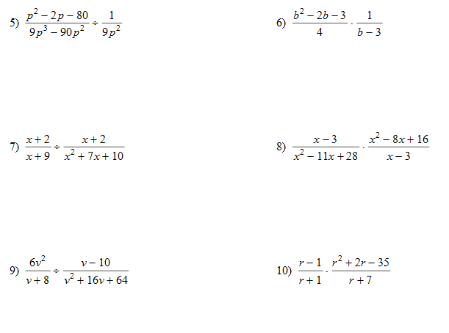

Choose the graph that represents the function. Determine the end behavior, y-intercept, and local max/min for each function.
