Analytic Geometry
FBM #2 Study Guide
Chapters 1-9

Geometry FBM#2 – # of questions by topic
- Properties 1
- Parallel lines (chapter 3) 1
- Congruent Triangles(chapters 4-5) 3
- Angles in a triangle 3
- Perpendicular/Angle Bisectors 1
- Parallelograms (chapter 7) 6
- Midsegment of a triangle 1
- Transformations 1
- Similar Triangles and proportional parts (chapter 8) 4
- Right Triangle trig (chapters 9-10) 4

- TP = TP
- If $m<A=m<B$ and $m<B=m<C$, then $m<A=m<C$.
- $2\left(x-3\right)=2x-6$
- If x = 8, then 8 = x.
- If 3x = 90, then x = 30.
- If $x = y$, then $x –2=y –2$.

- The measures of the angles of a triangle are m< A = 3x + 4, m<B = 2x and m<C = 5x – 24. Solve for x and m<C

- Find $m<G$
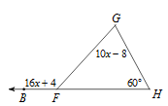

- Given: ∆ RGA and ∆PMC with $\overline{ RG} ≅\overline{PM}$, $\overline{RA} ≅\overline{PC}$, and $∠R ≅ ∠P$. Which method could be used to prove that ∆ RGA $≅$ ∆PMC? (Hint: Draw a picture)
a. SSS b. SAS c. HL d. ASA e. Not enough info.

Determine if the triangles are congruent. MARK your diagrams! If so, write a congruency statement AND state the method of proving them congruent. If not, write “no congruence”.
- 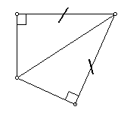 11. 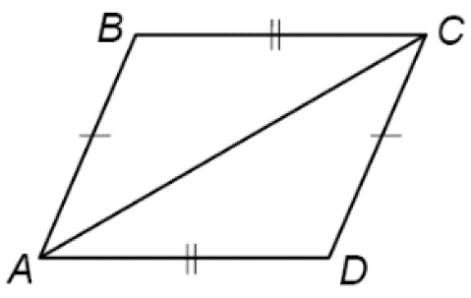 12. 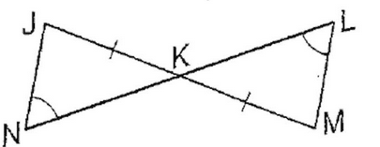
B
C
D
A

13. 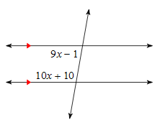 14. 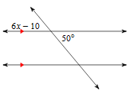
15. 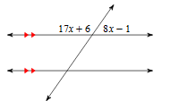 16. 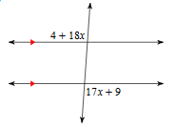

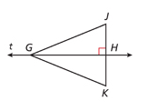
17. Given that line t is the perpendicular bisector of $\overline{JK}$and GK = 8.25, find GJ
18. Given that line t is the perpendicular bisector of $\overline{JK}$, JG = x + 12 and KG = 3x – 16, and JH = x-7, find KG and JH.

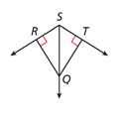
19. Given that GJ = 70.2, JH = 26.5, and GK = 70.2, find JK.
20. Given that $m∠RSQ=m∠TSQ$ and TQ = 1.3, find QR
21. Given that $m∠RSQ={58}^{°}$, RQ = 49 and TQ = 49, find $m∠RST$

For problems 22-23, find the value of x.

22. 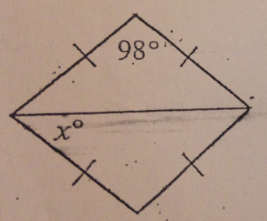 23. 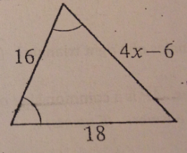

Use the given diagram to answer questions 24 - 26.
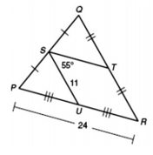

- ST =

- PU =

- QR =

27. Solve for x.
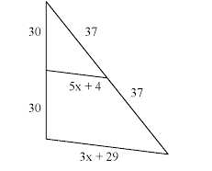

#’s 28-30 List the additional properties of the diagonals of the following parallelograms

28. Rectangle

29. Rhombus

30. Square

PQRS is a parallelogram. PT = 47, PS = 70, m<SPT = 20⁰, and m<QRS = 66⁰. Find each of the following measures.
31. RT 32. m < RSP 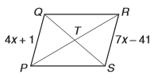

33. QR 34. If PT = 2x and PR = 6x-1, find PT

35. m < QPT 36. RS

PQRS is a rectangle. PQ = 44, PR = 72, $m∠SPT=({4t-5)}^{°}, m∠QRT=(3{t+7)}^{°}.$Find each of the following measures
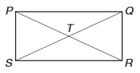
37. SR 38. m < PSR 39. TQ 40. m < QRP

CDEF is a rhombus. $The m∠EGF=({6y+9)}^{°}, m∠GEF={68}^{°}, and m∠GFE={22}^{°}.$ Find each of the following measures.
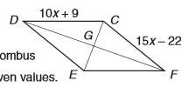 | - x  - EF  - y  - m<EFC

Given square ABCD
- If m< ABC = 6x-2, solve for x

- If m<ADO = 8x+5, solve for x

- If AB = x-5 and DC = 2x-7, Find BC

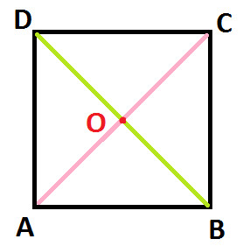

48. The scale factor ∆AEB to ∆DEC is 5:2. If DE = 7, then AE = ?

49. Find the scale factor: 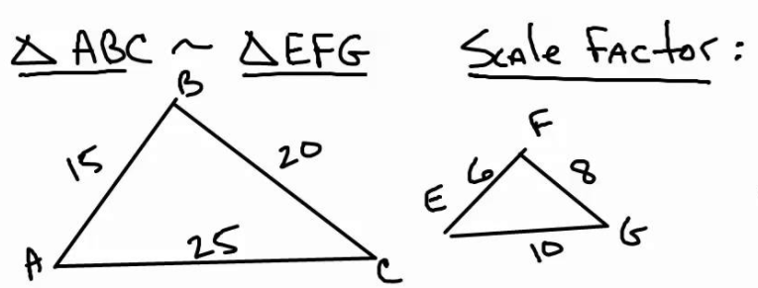

Determine if the triangles are similar. List the parts, the postulate or theorem used, and if similar, write a similarity statement. If not similar, show enough work to prove why.
50.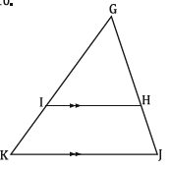 51. 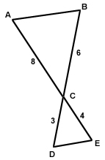

- Find the value of x. $\frac{3x+7}{4}=\frac{x+3}{2}$

- Find x
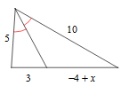

54. Solve for x.
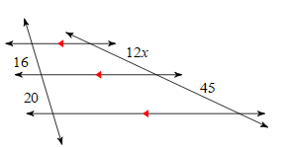
55. Solve for x.
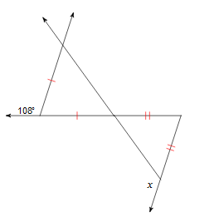
56. Write the following formulas
  - Pythagorean Theorem (Right Triangle)

  - 45-45-90

  - 30-60-90

  - Trig Ratios

57. Find the missing sides. 58. Find the missing sides.
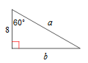
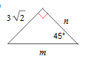

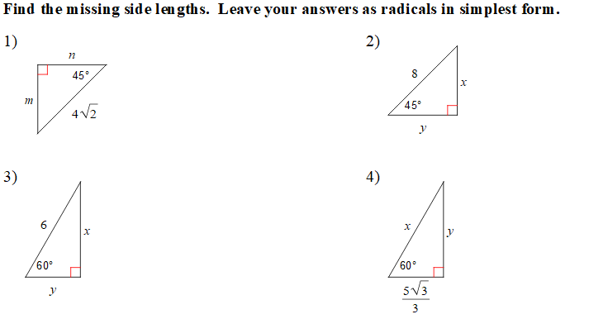

- Find the missing side in simplified radical form
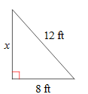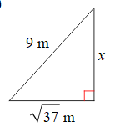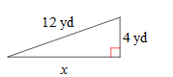

Express answers as a ratio and a decimal.

64. 65. 66.
