Name_______________________________ Accel Geom/ Adv Alg.
Date______________ Period ____________ Probability Review
1) A security code consists of 5 digits (0-9) and a digit may not be used more than once. How many possible security codes are there?

2) Amy must choose a password for her voicemail that consists of 3 letters followed by 3 digits. . She cannot use the letters A and Z or the digits 0 and 9. Each letter or number may be used more than once. What is the probability that her nosy brother guesses her password?

3) If one person is randomly selected from a class that has 6 sophomores, 12 juniors, and 7 seniors, find the probability that the person is a senior.

4) If a bag has 22 orange, 18 red, 12 green, and 8 blue marbles, what is the probability that in one draw you will not select a blue marble?

5) 2 number cubes are rolled. What is the probability that one roll is a “3” and the other roll is an even number?

6) You flip a coin and then roll a 6-sided die. Find the probability that the coin lands heads up and the die shows a one.

7) A) A jar contains 6 red balls, 3 green balls, 5 white balls, and 7 yellow balls. Two balls are chosen one at a time and replaced. What is the probability that both balls are green?

B) What is the probability if the balls are not replaced?

8) A box contains a penny, a nickel, and a dime. Find the probability of choosing a dime first, not replacing it, and then choosing a penny.

9) A box of chocolates contains 5 milk, 5 dark, and 5 white chocolates. You randomly select and eat 3 chocolates.
a) Find the probability that the first piece is milk, the 2nd is dark, and the 3rd is white

b) Find the probability that the first piece is dark, the 2nd and 3rd are white.

You roll two number cubes- one red and one black
10) What is probability that the red shows a multiple of 2 and the black shows a “5”

11) What is the probability that their sum is 6 or 8?

12) What is probability that you roll a even on red and the sum is less than 10?

13) What is the probability that the sum is greater than 7 given that the black cube shows an even number?

14) What is probability of getting a sum of 4 or a sum greater than 10?

15) What is probability of getting a sum that is even or a sum that is greater than 9?

16) Your teacher has a bag of candy to pass out. It contains 5 snickers, 3 skittles, 4 hot tamales, and 7 starburst. You get to select 3 candies from the bag. What is the probability that you select all 3 skittles?

17) Each letter of the word SAMSUNG are on separate cards, face down on the table. If you pick a card at random, what is the probability that you pic the letters S or U?

18) A store owner is keeping track of customers and whether or not they make a purchase. What is the probability that a customer from this group makes a purchase?
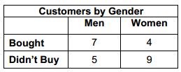
19) A bag contains 10 beads, 2 black, 3 white, and 5 red. A bead is selected at random. Find the indicated probabilities.
- Selecting a white bead, replacing it, and then selecting a red bead

- Selecting a white bead, not replacing it, and then selecting a red bead

- Selecting 3 non-red beads without replacement

20) The number of students enrolled in several classes is represented in the Venn Diagram. Determine the total number of students for the following problems.
$$a) (S∩C)∪M$$
$$b) M'$$

$$c) \left(S∪C\right)'∩M$$

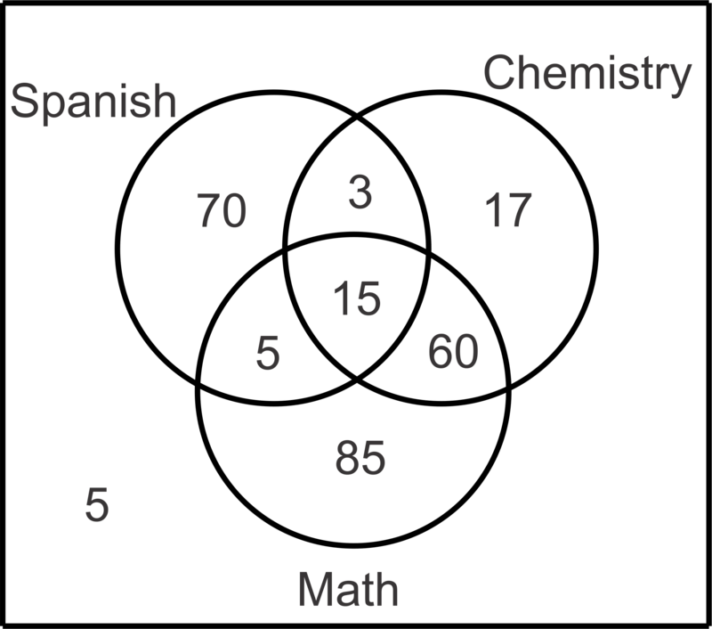
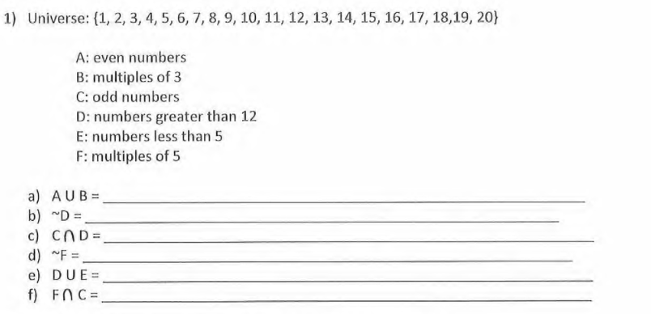
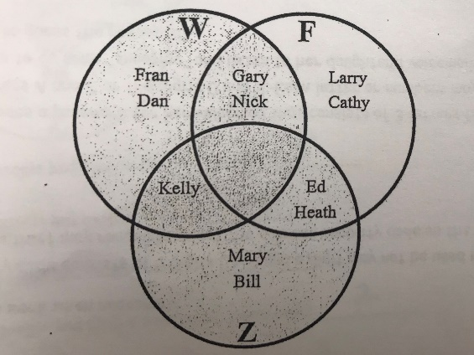
- How many people had been to the water park?_________
- How many people had ONLY been to the fair? __________
- How many people had been to the zoo? _________
- How many people had ONLY been to the water park?______

22) The diagram shows the different places students had been in the last year; water park (W), fair (F), and zoo (Z).
23) $W∪Z$ __________________________________
24) $Z∩W$___________________________________
25) $W'∩Z'$__________________________________
26) $(W∩Z)∩F'$_______________________________
27) $(F∪W)∩Z'$_______________________________
28) $W'$_____________________________________
29) $(W∩Z)'$_________________________________
30) $W∩F∩Z$________________________________

Given a standard deck of 52 cards, find the following probabilities.
31) Drawing 2 cards at random and getting an ace and a 4

32) Drawing a Queen given it’s a face card

33) Drawing a red card or a 6

34) Picking a heart or a diamond.

35) Picking a heart, putting it back in the deck, and then picking a diamond.

36) P(4|Black)
37) Drawing a red card, replacing it, and drawing an ace.

38) Drawing a face card or a black card

39) Drawing a spade, a diamond, or a multiple of 5

40) Drawing a card with a number less than 4 or drawing a jack.

41) Drawing a 3, not replacing it, then drawing the Queen of Hearts.

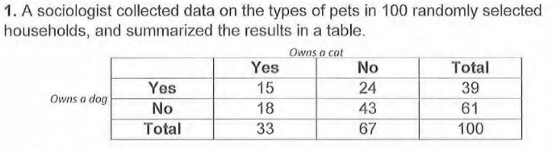
42) Create a table of the joint and marginal relative frequencies.

43) P(owns a cat)

44) Probability that they own a dog given that they do not own a cat

45) Probability that they do not own a cat and do own a dog

46) P(does not own a dog|own a cat)
47) Of the 65 students going on a soccer trip with their school, 43 are players and 12 are left-handed. Only 5 of the left handed students are soccer players.
a) What is the probability that one of the students on the trip is a soccer player or is right handed?

b) What is the probability that one of the students is not a player or is left-handed?

Table below shows results of a survey of 10th-12th graders if they own an I-Phone.
 | Owns I-Phone | Doesn’t Own I-Phone
10th Grade | 204 | 270
11th Grade | 192 | 160
12th Grade | 198 | 165
48) Given the student is a 10th grader, what is the probability that they own an I-Phone?
49) What is the probability that the student is a 11th grader or a 12th grader?
50) What is the probability that a student is a senior who doesn’t own an I-Phone?
51) What is the probability that the student is a 10th grader given they own an I-Phone?
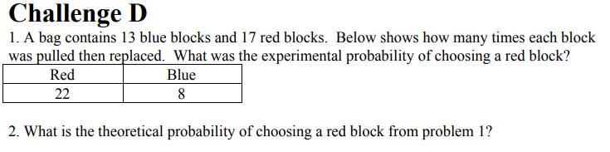
You toss a dice 30 times and recorded the results in the table below.
# on dice | Results  54. Find the experimental probability of each:  P(1)= P(2)= P(3)= P(4)= P(5)= p(6)=  55. Find the theoretical probability of rolling an odd number or a number greater than 1?  56. What number had an experimental probability that matched the theoretical probability?  P(4)= P(5)= P(6)=
1 | 3
2 | 8
3 | 7
4 | 5
5 | 3
6 | 4

