Name__________________________ Advanced Algebra
Date_______________ Period______ Spring BM 1 Review

Find the characteristics listed for each rational function. Graph using an x/y table.
- $f\left(x\right)=\frac{1}{x-1}+3$ 2) $f\left(x\right)=\frac{1}{x+2}$

Vertical Asymptote:_____________ Vertical Asymptote:___________
Horizontal Asymptote:___________ Horizontal Asymptote:__________
Domain:______________________ Domain:_____________________
Range:________________________ Range:_______________________

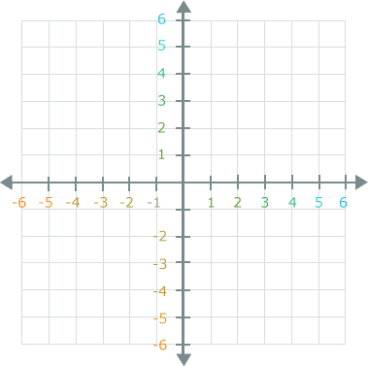
For problems 3-5, write a rational function given the characteristics.
3) zeros at -1 & 3, vertical asymptote at x=0 & x=2

4) zeros at 0 & 7, vertical asymptote at x=-2

5) zero at -3, vertical asymptote at x=1, hole at x=9

Find the characteristics listed for each rational function. Graph using a graphing calculator.
6) $f\left(x\right)=\frac{4x+12}{x^{2}-3x-18}$ 7) $f\left(x\right)=\frac{{2x}^{2}+2x-12}{x^{2}-9}$
Hole(s):____________ Hole(s):___________
Zero(s):____________ Zero(s):___________
Vertical Asymptote(s):______________ Vertical Asymptote(s):_______________
Horizontal Asymptote:_____________ Horizontal Asymptote:_______________
Slant Asymptote:__________________ Slant Asymptote:____________________
8) $f\left(x\right)=\frac{x^{2}-3x-4}{x-4}$ 9) $f\left(x\right)=\frac{x^{2}+2x-8}{x-1}$
Hole(s):____________ Hole(s):___________
Zero(s):____________ Zero(s):___________
Vertical Asymptote(s):______________ Vertical Asymptote(s):_______________
Horizontal Asymptote:_____________ Horizontal Asymptote:_______________
Slant Asymptote:__________________ Slant Asymptote:____________________

